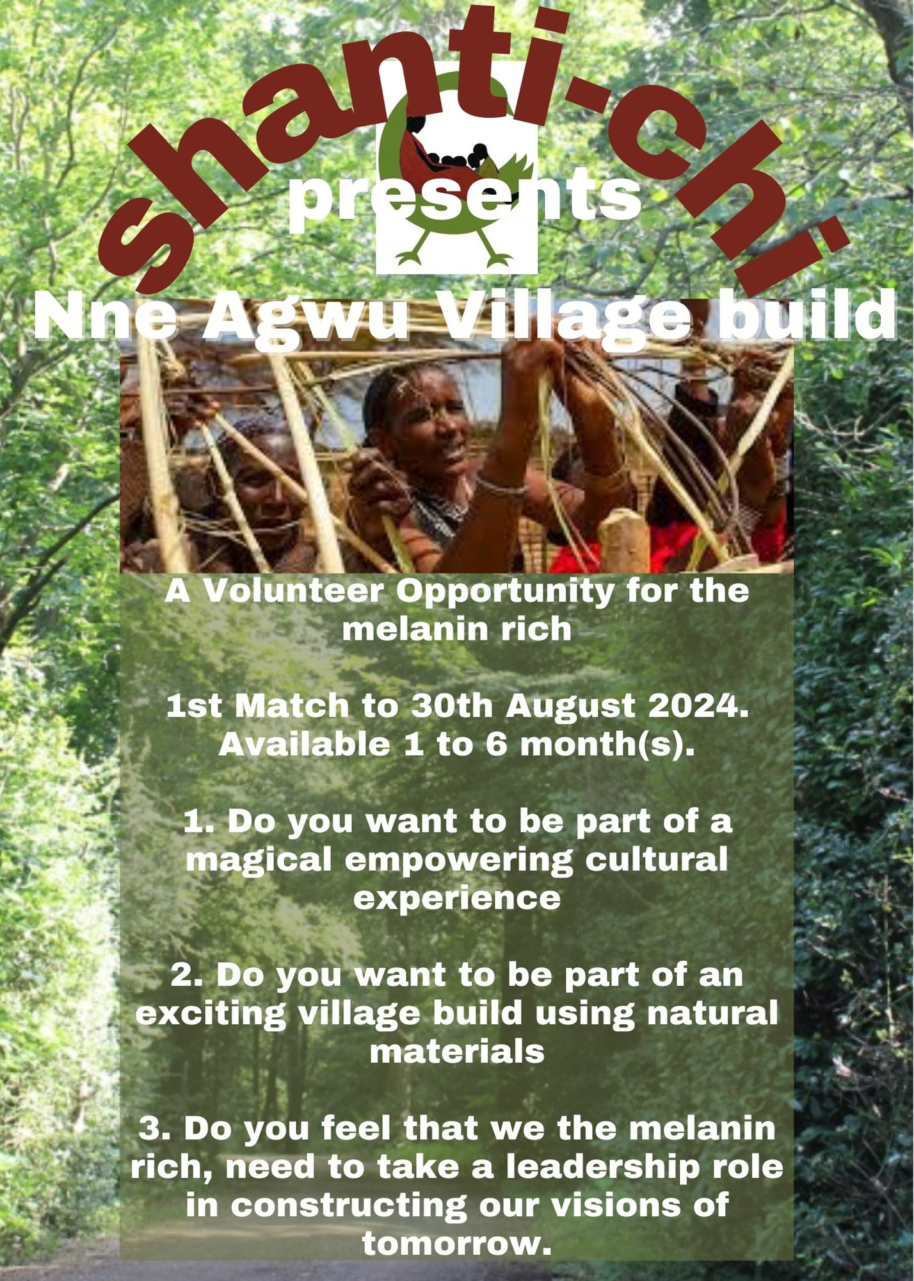
JOURNEY TO GHANA
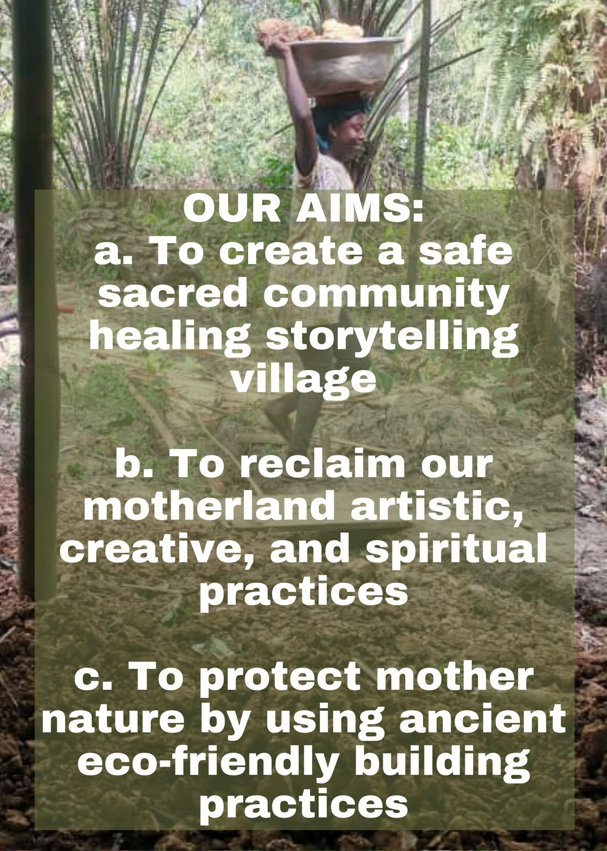
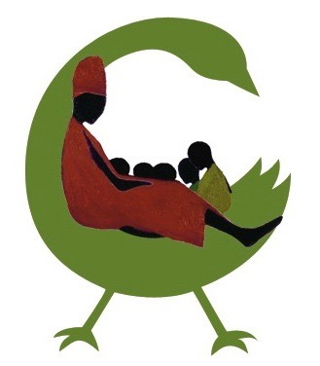
Thank you for choosing to support this amazing project with your time and energy. The Nne Agwu village build is vision given to Griot Chinyere by the divine forces of the cosmos. And can only be actualised by the time energy and love of the souls living in melanin rich bodies. You have chosen to be a part of this because you have a calling. We look forward to sharing quality healing and divine times with you, as we build our safe sacred space.
Shanti-Chi
presents

Nne Agwu Retreat

HOW TO BOOK
- Read TERMS OF USE on the webpage: https://www.shanti-chi.com/terms-of-use.
- Complete a volunteer form found: https://www.shanti-chi.com/nneagwu-build webpage
- Return form to info@shanti-chi.com with deposit
- Book your flights
- Check visa requirements
- Apply online for Visas: https://ghanahighcommissionuk.com/london-offices
- Give yourself 3 weeks minimum before flight date to apply for visa
- We will support you with your visa requirements

Essentials:
- You will need a valid passport with at least 6 months left
- You will need a valid visa and travel documents for immigration clearance.
- You will need a Yellow Fever Vaccination Card showing that you have been vaccinated.
- Or
- You will need an exemption letter written by you, or your health care practitioner or notorised from a solicitor, outlining your reasons.
- You are advised to have appropriate travel insurance which includes medical insurance.

Health Guidance Notes:
Please note we strongly suggest you eliminate as much as possible alcohol, sugar, diary, meat and fish from your diet at least 6 weeks before your flight to Ghana. It will help as an insect repellent, protect your well-being and support your good health during this time. Drink plenty bitters such as neem leaf, cerasise, rice bitters, bitter leaf and any others you know. Eat plenty dark green leaves (spinach, kale, corriander, basil, rocket, cavollo nero, cabbage, leaves from cauliflour etc) Make them into a smoothie. These green leafy veg in their raw state will detox and clean out toxins from, the colon. Drink as much as possible during the 6 weeks leading up. Water is to keep you hydrated and flushed. Hydration flushes out bacteria and prevents deseases taking a hold of the body. “I like to fast 24 hours before I travel to Africa”. Griot Chinyere

I strongly suggest daily exercise of mind, soul and body with regular walking round the block or to the park/forest/woods/along a beach/up a hill, day or night; stretching with friends or solo, dancing around the living room, martial arts, breathwork etc. These exercises help build stamina and core strength

The price includes a 7 day detox which we will do together 6 weeks before the Nne Agwu retreat.
Preventative receipes for on the Motherland to keep you safe:
- Nutmeg- (chew or boil a tiny bit to halt a ‘running’ belly.)
- Thyme- (boil tea for upset stomach, bowel cleanser.)
- Rosemary and Lavender to sooth bites
- Bring your first aid kit

Spray blend
In a 1 litre spray bottle of water pour 10ml of lemon grass essential oil, a small drop of natural soap and drop of garlic oil or clove into the water bottle. Use this to spray your room, space, tent, and clothes. Carry an empty spray bottle with you, carry essential oils in your suitcase though I do believe you are allowed to carry 10ml liquids in hand luggage.

Body blend
300ml of shea butter, 200ml of Neem oil, 100ml of vitamin E oil, three table spoons full of coconut oil and 27 drops of lemon grass essential oil.

Internal and external
Collodial silver considered as the immortality medicine, can be used internally and externally. Internally it heals the body of bacteria, parasites, and fungal infections. Externally it heals the body of infections, cuts, bruises. It works effortlessly.
Grate tumeric, ginger and garlic into already hot water. (Not too hot) then let it sit for 30 minutes. when what you need has seeped into the water then drink. It is refreshing and acts as an internal cleanser.

After the bite
Arrow root powder - add small amount of cold water and stir. Then add some hot water & stir into a smooth paste. This paste can be applied onto insects bites. It will draw out the impurities and kill parasites trying to take over the body. It supports healing. It is very Powerful!

*If you are following a healing regime or are on any medication to treat existing conditions respiratory or otherwise, kindly ensure that you consult your health / well being practitioner before travelling.

Etiquette
*Please avoid bringing clothes you intend to give away, as there are already many second-hand clothes sellers in Ghana and the local fabric industries and tailors are suffering as a result. As a valued alternative, please do bring any educational/ story books or magazines on current philosophy, Folktales, Afrakan technology and inventions for local communities. Things that reaffirm that melanin is rich and an asset to all those who are rich with melanin.

- Come with an open mind to learn / to listen, and not with a colonial mind to teach / to tell
- Ask host how much ought to be before going to market then you can choose if you want to pay more
- Avoid making empty promises: Learn to listen to people’s woes without feeling the need to solve the problem. Sometimes we can find answers without it costing money. Leave the white saver mentality behind.
- Always question yourself and your motives for doing things.
- If you feel impassioned about something and want to do something then find a melanin rich organisation already tackling the issue and join them.
- Remember your manners, people are not your servants or slaves.
- Respect everyone you meet.
- If anyone is bringing someone into the village for the day or over night, it must be done with prior agreement & relevant offerings made 48 hours in advance.
- All Nne Agwu village members are their sisters and brothers keeper. We are all responsible for each other.
- Be cautious about romancing, people are looking for someone to get them a passport to Britain.
- Nne Agwu is looking for people to join the team to build the village with integrity and divine energy.
- Speak with Griot Chinyere if you wish to live on the Motherland. Those who have volunteered for a village build and also attended a retreat, whether on the motherland or in the UK, are legible to buy one of our limited, 9 plots for sale.

Ultimately you are responsible for your own health and well-being. And we are here to support you!

What to bring with you
Here are a few suggestions for what to bring with you. This is not an exhaustive list, so please think of what essentials you will need to make you more comfortable while here, in Ghana.

- Light loose comfortable cotton clothes: Trousers, long sleeves tops, long skirts and dresses, head wraps, big rimmed hats and sun glasses to shade from sun and prevent insect bites to face, cotton face clothes to wipe sweat, cotton gloves, socks and knickers.
- Comfortable walking boots for hikes, sandals for keeping cool, flip flops for the shower wash room, wellington boots / work boots.
- Rechargeable lamps and torches: wind up are best expecially for the night.
- Light rain-coat/ jacket WITH A HOOD. Umbrella for shade and rain
- Solar power packs for recharging, though there will be 7 days without phones.
- Essential oils are great as the scent remains on the clothes and contiues to work. Lemon grass essential oil (2 x 10ml), Neem oil (200ml), bitters leaves (Neem, lemon grass), spray bottle (1 litre size), garlic (10ml essential and 1 bulb), tumeric, vitamin E oil: ingredients to help with creating recipes for protect
- Small sewing set - needle and thread
- Ear plugs - for the sounds of the night are joyous!
- Water filters: Aim to drink 2 to 3 litres of water daily.
- Bring secure candle holders for your candles

How to Bring your Money
- Please note that very few banks will change ‘travelers cheques’.
- Bring Visa or bank cards as there are many banks with ATM facilities.
- Please note that Mastercard credit card ATM facilities are available at certain banks.
- Be sure to get clearance from your bank for using your credit / debit card here to withdraw cash.
- ATM is in Ho 30 mins drive away from Nne Agwu village.
- You will probably spend money on excursion days. We will stop off at ATM

Yo Yo Yo enter the Nne Agwu village: a safe sacred space on the Motherland in nature’s embrace. Where we souls living in melanin rich bodies will engage in building structures using natural material. Be prepared to get you problem solving head on and find solutions. Lets wear our pioneering cloak to remind us that we are doing something amazing.

